Chapter 1: Introduction
  - Background
With manufacturing moving towards using more lightweight, durable, and renewable sources, materials like carbon fiber have been in the spotlight. While using molds and other manufacturing methods are more efficient for creating a large quantity of carbon fiber products, it is the low quantity, complex items that are an issue because of their low quantity, the price to manufacture that item and the price for the consumer becomes higher.
As such, Dieless forming methods like 3D printing and incremental forming possess a unique opportunity to fill this need. Dieless forming methods allow for the manufacture to manufacture the low quantity items at a lower cost making those items cheaper for the consumer.

  - Research objectives
The goal of this paper is to improve upon the python code from a previous project, so that a clean toolpath can be generated to be used in incremental forming using CFRTP as the material.

Chapter 2: Basics
2.1 Incremental forming technology
2.1.2 Development history
Incremental forming is a manufacturing method first proposed in Japan in the 1990’s. The goal of this manufacturing method is to make a dieless plastic processing method for low volume, complex items. Incremental forming is a general term for the processing of plastics without dies and includes various techniques such as hot forming and local heating. In general, Incremental forming methods have five main characteristics:
- High degree of freedom in moldable shapes
- Not requiring a mold
- Forms thin shell shapes
- High forming limit for metal sheets
- Creating complex shapes that are in low demand

2.1.3 Different types of incremental forming
There are two main types of incremental forming, dynamic and static. Dynamic incremental forming, which uses kinetic energy to form the shape out of the material. An example of this is the shot peen method where millimeter sized shots made of various materials like steel, glass or ceramic, are shot at the material that you want to shape. Static incremental forming slowly stretches the material into the required shape. In this research paper, static incremental forming will be the method that we are using.

    - Uses of incremental forming
Incremental forming methods are useful for a variety of things like prototyping, creating custom parts for cars, and testing the characteristics of new materials. A real-world example of where incremental forming is used is in the LEXUS LC, EDGE produced by the Toyota Motor Corporation. The part of the car that uses incremental molding is in the plastic bumper at the front of this car.

2.2 NC machine tools​
    - Overview​
NC machines, or Numerical control machines, are machines that can be controlled with a set of numerical commands. The commands given to the machine can determine things like the position and speed of the tool. A series of operations related to machines can be executed by programmed commands. This allows machines to do what was previously done manually by humans to be automated, shortening processing times, improving productivity, and reducing labor costs. In recent years, a control method called CNC, which is a form of computer-based numerical control, has become common.
An NC program is a program for automatically operating NC machines. A program consists of blocks, which are the individual lines like the one below:
G01 X8 Y10 Z9;
Blocks are generally broken up into two different parts, the Function section (G01) and the coordinate section (X8 Y10 Z9;). The NC program also can be programed to control the start and end of machining with specific notation specified in the table bellow (Table X). Depending on the function that you want, the function section (G01) will change. The following are general descriptions for the different types of functions.
- G-Code
  - General Functions become preparatory functions in G-code and NC programs
- M-Code
  - Miscellaneous Functions are M-codes, auxiliary functions, and are primarily used for commands other than movement.
- F-code
  - Control the F-code and feed speed from Feed Functions.
- S-Code
  - S-code controls the spindle rotation speed.
The following table has the functions that are used in the G-code during this research.

G Code | Positioning |  | G00
G Code | Linear interpolation |  | G01
G Code | Circular interpolation | Clockwise | G02
G Code | Helical interpolation | Counter clockwise | G03
G Code | Plane Selection | XY Plane | G17
G Code | Plane Selection | YZ Plane | G18
G Code | Plane Selection | ZX Plane | G19
G Code | Inch input |  | G20
G Code | mm input |  | G21
G Code | Local coordinate system settings |  | G52
G Code | Machine coordinate system selection |  | G53
G Code | Work coordinate system selection |  | G54-G59
G Code | Absolute coordinate command |  | G90
G Code | Relative coordinate command |  | G91
G Code | Work coordinate system settings |  | G92
M Code | Spindle section |  | M03
M Code | Program end |  | M30
F Code | Feed Speed (mm/min) |  | F5
S Code | Rotation Speed (RPM) |  | S5
Table 2.1: G-code functions
2.2.3 3D CAD
CAD (Computer Aided Design) is software for designing on a computer. CAD can be broadly divided into two types: 2D CAD and 3D CAD. With improvements in technology, 3D CAD has been widely adopted in various industries. 3D CAD design software allows for easy planning of prototypes so there are less errors in the production of the products. All test pieces and molds in this research paper were designed using CAD to be manufactured and tested.
2.2.4 CAM
CAM (Computer Aided Manufacturing) is software that creates machining programs for NC machine tools on a computer. Before CAM, workers had to input NC data directly into the machine tools, increasing the time for manufacturing and costs. As mentioned in the G-code section, CAM eliminated this process, speeding up the manufacturing process. In addition, because it is possible to visually verify the machining process through machining simulation, it allows the manufacturing to be even more efficient.

    - Tool path​
A tool path is the path along which a machining tool moves. A tool path is created using the 3D coordinates of an STL file from CAD software to obtain a collection of all the points or point cloud from the triangles of the STL file. From this you sort the points, delete the duplicate points, generate a set of coordinates, then add the necessary pieces so that the coordinates turn into the NC program. The NC program can be used to instruct the machining path of the tool. The toolpath was viewed using a web browser called NC viewer to identify any potential issues before any manufacturing was done.
    - Python
Python is a programming language that is widely used and known for its simplicity, readability, and versatility. Python allows developers to condense programs in fewer lines of code compared to other languages like C++ or Java. In this research, Python was the programming language of choice to develop the CAM system used to produce the toolpath for its easy understanding and application. The code for the CAM system will be explained in a later section.
2.3 CFRP (Carbon Fiber Reinforced Plastic)
    - Overview
Carbon fiber Reinforced plastics or CFRP, is a general term for plastics that have been reinforced with carbon fibers. The reinforcement allows CFRP to have high strength and rigidity compared to metal materials such as iron and aluminum but also being significantly lighter. It also has excellent design and vibration absorption capabilities. As such, there has been an increase in the use of CFRP in many things like aircraft wings, car parts, sports equipment, and even medical uses.
2.3.2 Classification of CFRP
CFRP is classified into two types, Thermosetting CFRP (CFRTS: Carbon Fiber Reinforced Thermo Sets) and Thermoplastic CFRP (Carbon Fiber Reinforced Thermoplastic) CFRTS’s are typically used for weight reduction in sports equipent, aircraft, etc. CFRTS has the following characteristics:
- High specific strength, high heat resistance
- Long molding time, high cost
- Not possible to recycle
CFRTP is also used in similar situations to CFRTS and has already been used in some automobile parts which will be discussed in a later section. CFRTP has the following characteristics:
- Specific strength and heat resistance are inferior to CFRTS
- Short molding time, low cost
- Partially recyclable
CFRP can be also divided into two other classifications depending on which direction the plastics in the CFRP are oriented. The two sections, continuous fiber and discontinuous fiber have the following characteristics.
Continuous fiber CFRTP:
- Layered structure
- High specific strength
- Low press formability
Discontinuous fiber CFRTP
- Integrated structure, random orientation
- Specific strength is inferior to long fibers
- High press formability
2.3.3 CFRP application areas
As mentioned briefly in the previous section, CFRP can be used in various fields. In aircraft and car parts, CFRP is used in conjunction with other materials to make more efficient parts. Things like airplane wings and car parts like bumpers. CFRP can also be used in the medical field in things like head braces for brain surgery to allow x-rays of the brain to be taken while keeping the patients head stable, to a socket for prosthetics, taking advantage of its light weight to reduce the overall weight of prosthetics.
2.3.4 CFRP sample used in this study
In this study, discontinuous fiber CFRTP is used for its short molding time, low cost, and its recyclability.

2.4 Previous research A (Incremental forming of CFRTP under thermal bath conditions using oil bath and the creation of a CAM system using Python language.)
    - Overview
The goal of this previous thesis is to create a CAM system using python to perform incremental forming for discontinuous fiber-reinforced thermoplastics (CFRTP) using an oil bath to heat the CFRTP to enable incremental forming without molds. The previous researcher developed a custom CAM system in Python to generate G-code tool paths from CAD models, targeting low-volume, high-mix production needs. The python code can be seen in the next section.
The study addresses challenges with traditional manufacturing like high mold costs and limited flexibility, especially in forming thin shell components. It introduces a cost-effective alternative that combines material heating via an oil bath and open-source digital toolpath generation.

    - CAM and CAD system
The CAM system that was created achieves three goals, to read STL files from Creo Parametric 4.0., Extract 3D point clouds of target shapes, and create a tool path in G-code. The code achieves this by using pythons’ libraries as seen in figure X to create a point cloud from the STL file, converts the clouds into layers by Z-height then connects the points in each layer by the minimum Euclidean distance. Finally, it takes the coordinates and adds the proper syntax to be used by the CNC machines.
The Shape that was created in Creo was a truncated cone with varying dimensions. The radius of the shape ranges from 20, 30, and 40 mm, and similarly the wall angle 30°, 40°, and 50°, and the pitch or the resolution of the STL was 1. The dimensions were selected to match the working area and limitations of the experimental setup. The shape was chosen because it is a good shape for a proof of concept, especially for plastic deformation layering.

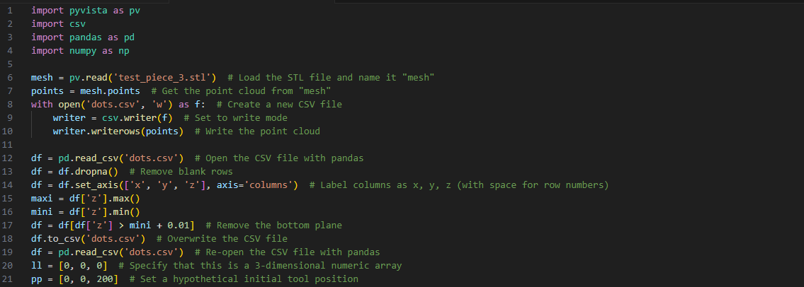
Figure 2.1: Initial setup

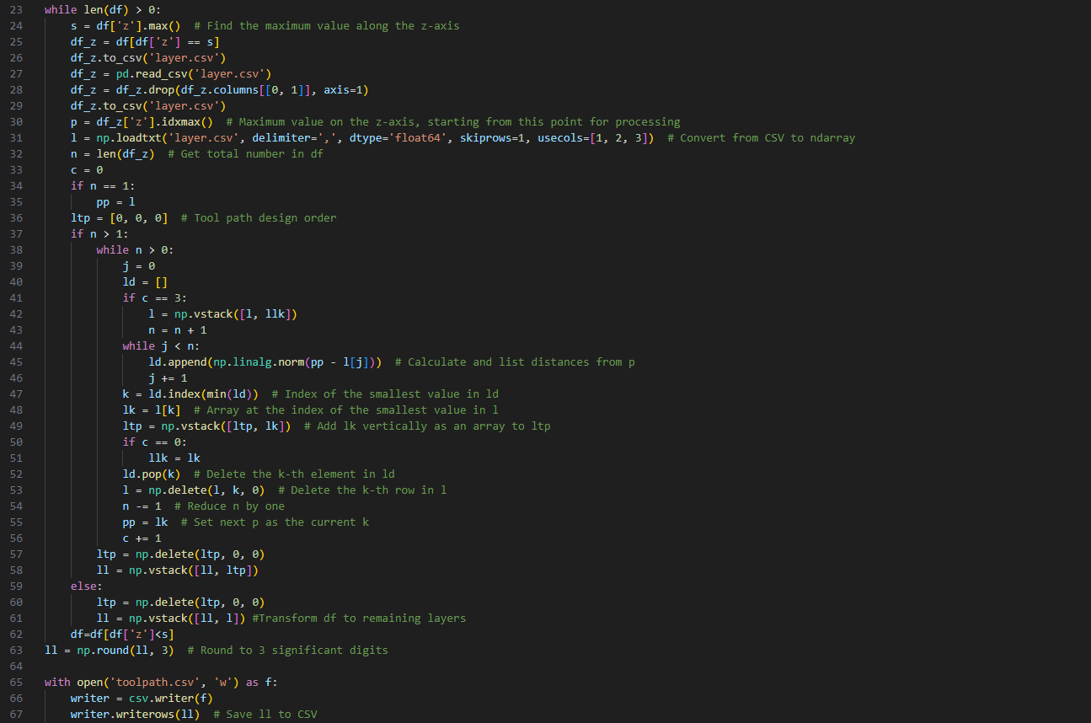
Figure 2.2: Toolpath generation

Figure 2.3 Finishing touches.
2.4.3 Experimental equipment:
In the previous research the following equipment were used, most of the materials used in the previous experiment will be used in the research and will be explained more in detail in a later section.
- CFRTP sheet (PA6 matrix, 20 wt% carbon fiber)
  - Size: 110 mm × 110 mm × 1 mm
  - Dried at 120°C for 24 hours using an ETTAS oven to prevent moisture-induced degradation.
- Heating Equipment:
  - Oil bath: T-22H model (Thomas Scientific)
    - Temperature range: up to 200°C
    - Precision: ±0.2°C (PID controlled)
    - Stirring method: jet circulation
- Oil used: KF968 (Shin-Etsu)
  - Non-volatile, stable to 250°C, fire-resistant
- Forming System:
  - CNC Machine: Sodick MC430L
    - Travel: X 420 / Y 350 / Z 200 mm
    - Feed: up to 36 m/min
  - Tool (Mandrel): SUS304, 5 mm dia, 2.5 mm radius tip, 60 mm long
  - Custom jig submerged in the oil bath with secure clamping and easy detachment for safety and repeatability.
2.4.4 Results
From the experiments that were done, it was found that there were several factors that contributed to a successful forming which were, the temperature of the material, the tool rotation, wall angle, radius variations. The temperature that was achieved the best results ranged from 180–200°C (453–473 K) and the lowest temperature that had a successful forming was 323 K. Below 160°C (433 K), material failed to deform properly, often leading to cracks.
It was also found that the rotation of the tool at 1000 rpm played a big role in increased depth and smoother walls. When there was no rotation the finish on the surfaces were poor and tended to have uneven wall thickness.
The angle of the wall had some influences on the forming. The best wall angles tended to be both 30° and 40°. At these angles, it was found that there was smooth forming, minimal springback and when it was closer to 40° there was some deformations that were observed. Anything that was 50° or greater had risks of cracks and breakage.
The radius of the shape also played a big part in forming, it was found that the smaller the radius (20 mm) there was a deeper forming depth but a much higher wall stress, and 40 mm produced less depth but more uniform wall strength.
The maximum and minimum criteria for a successful forming was the following:
  - Maximum: 14.9 mm at 200°C, 20 mm radius, 40° wall angle.
  - Minimum: 3.6 mm at 160°C, 50° wall angle, without rotation.
2.4.5 Conclusions:
The researcher successfully created the Python CAM System and was able to successfully generated tool paths from STL data, that also smoothed the process of incremental forming, improved the flexibility of the existing toolpath generation methods, and allowed the support arbitrary shapes, ultimately creating a system that could be used in production environments.
The CAM system that was created in this previous research A was used as a starting point for the CAM system that will be shown later, there are a lot of similar aspects but also some improvements from what is shown here.
Chapter 3: Experimental tools
  - Machining center
The tool path used in incremental forming is the same as the G code used by normal machine tools. Therefore, incremental forming can be done by customizing a machining center without purchasing a dedicated machine. In this study, a general-purpose machining center, a precision linear nano machining center (MC430L) from Sodick Co., Ltd was used. By attaching an incremental forming device and an oil bath to this machining center , it became possible to perform incremental forming. The figure bellow shows what the machine center looks like.
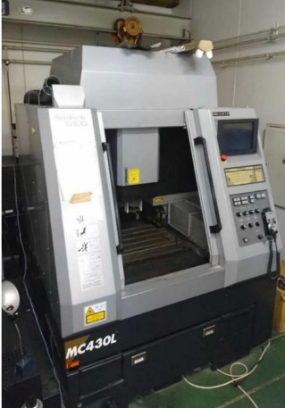
Figure 3.1: Appearance of M C430L

  - Python
As mentioned in a previous section, Python is an open-source programming language known for its simplicity, readability, and versatility. It's widely used in fields like data science, web development, automation, machine learning, and computing. The easy accessibility, simple syntax, and large amount of libraries that help with specific tasks are some of the reasons why it will be used in this research.
As mentioned before, Python is used to build a CAM system that will take STL data and generate G-code for CNC machining.
  - Discontinuous CFRTP
As mentioned earlier in this paper, this study will be using discontinuous CFRTP as the test material. The integrated structure, random orientation of the fibers, and high press fomability are all reasons for the use of discontinuous CFRTP. The CFRTP sheets that will be used are (PA6 matrix, 20 wt% carbon fiber), the dimensions will be Size: 110 mm × 110 mm × 1 mm, and it will be dried at 120°C for 24 hours using an ETTAS oven to prevent moisture-induced degradation during the incremental forming.
  - Oil bath
The oil bath that will be used in this experiment is the oil bath that was used in the previous experiment, the T-22H model (Thomas Scientific). The oil bath can reach temperatures up to 200°C, has a precision of ±0.2°C and uses jet circulation to move the oil around ensuring that the heat of the oil is uniform.

  - Type of oil
    - The silicone oil used is Shin-Etsu Chemical's K F968 . The liquid used in the oil bath must be resistant to temperatures between 323K and 473K due to the characteristics of the sample . It is also necessary to ensure safety during experiments.
    - -High temperature resistance
      - Low thermal degradation (anti-spontaneous combustion )
      - Low volatility
    - This oil is used to satisfy the above points. The appearance is shown in Figure 3.4 below, and the specifications are shown in Table 3.4 .


Figure 3.2: Appearance of KF968

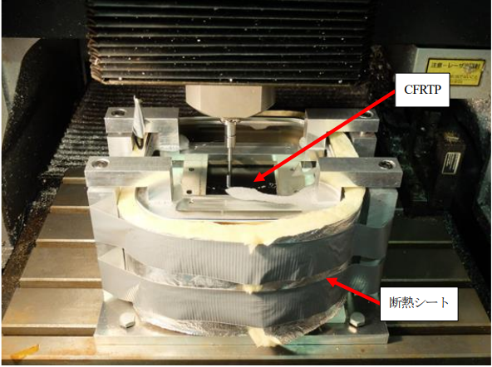

Figure 3.3: Incremental stretch forming with hot water assistance in oil bath ( 2017 )

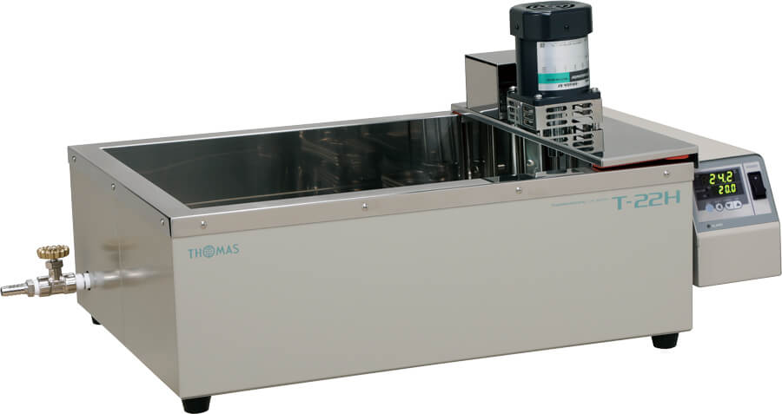
Figure 3.4: Appearance of T -22H [ 19 ]

  - Forming tool
In this study, a 5 mm diameter rod with a 2.5 mm rounded tip was used as the tool. The mandrel diameter was the same as that of the mandrel used in the previous study. In addition, due to the offset of the incremental forming device attached to the machining center, the length of the rod was set to 60 mm. The material was SUS304.

  - Master mold
To prove that the shape could be manufactured using incremental forming, a preliminary test was done using a 3D printed mold and will be briefly mentioned in a later chapter as this is an important step but not the focus of this paper
  - CFRTP dryer
When the base material resin is heated, deterioration of the resin is expected at high temperatures. It is known that the presence of water in the material has a large effect on deterioration. PA6 resin, the base material used in this study, is also hygroscopic, so the CFRTP must be thoroughly dried before processing to remove the chance of deterioration. To achieve this, the ETTAS MOV-450S from AS ONE Corporation was used to dry the CFRTP. In the figure below the ETTAS is shown. The ETTAS can be set from room temperature to about 240 K and is the size of the oi heating area is 445 mm x 440 mm x 650 mm.
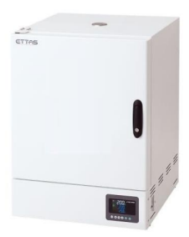
Figure 3.5: Appearance of the constant temperature dryer
  - Jig Dimensions
To hold the CFRTP and oil in place while forming, a Jig is required. The upper frame of the jig is removable and is able to secure the CFRTP. This improves work efficiency and safety. In Figure X we the dimensions are shown and in Figure X what the jig looks like is shown.
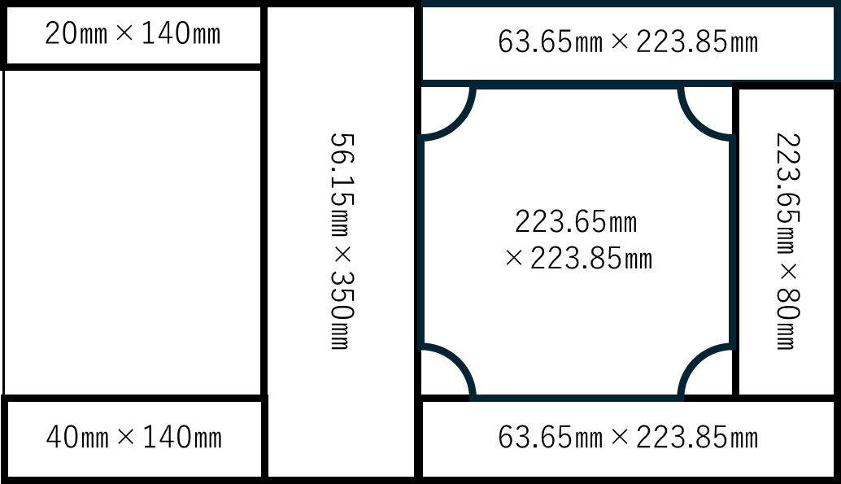
Figure 3.6: Jig dimensions
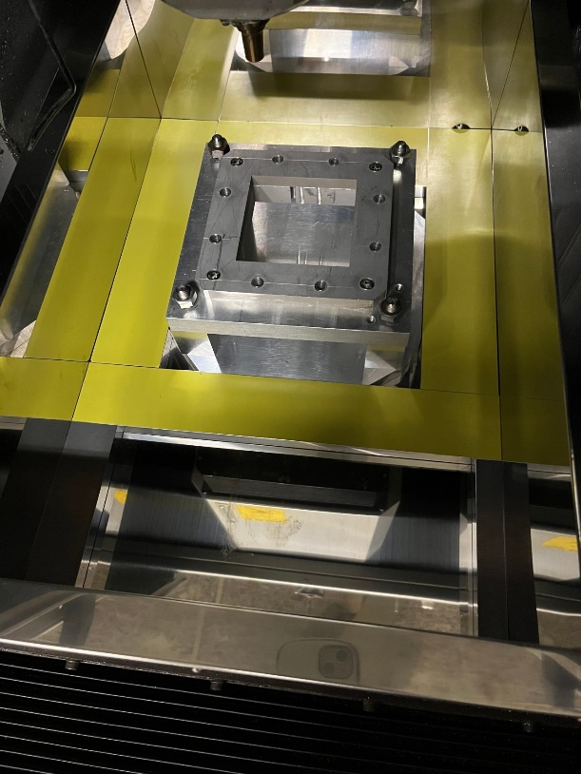
Figure 3.7: Jig arrangement (actual)

Chapter 4: Toolpath generation
  - Breakdown of the program
The programming language Python is used to develop the CAM system for the toolpath generation because it was mentioned in the previous chapter. The CAM system below is based on previous research’s CAM system, however, adjusted for more complex shapes rather than just a truncated cone. The following code is divided into four simple sections, which will be explained in the following sections.
The general flow of the program goes like this. Import the STL data from the design software-> setup of the variables, libraries, and tool path logic -> toolpath generation and g-code conversion-> compiling and finishing touches, and can be shown in the figure below.
Figure 4.1: General outline of CAM program

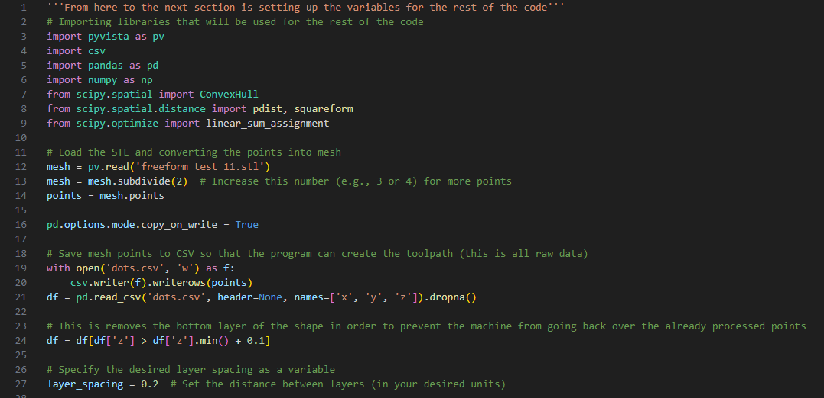
Figure 4.2: Variables and library setup

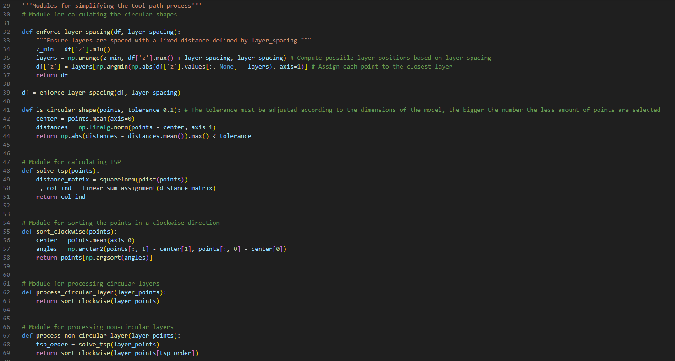
Figure 4.3: Setting up logic for the tool path generation

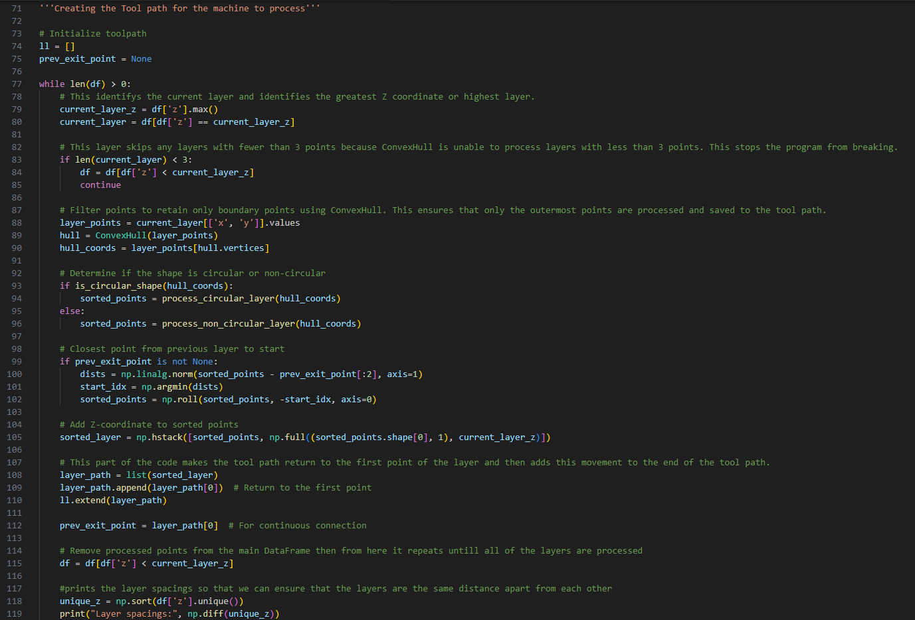
Figure 4.4: Tool path generation
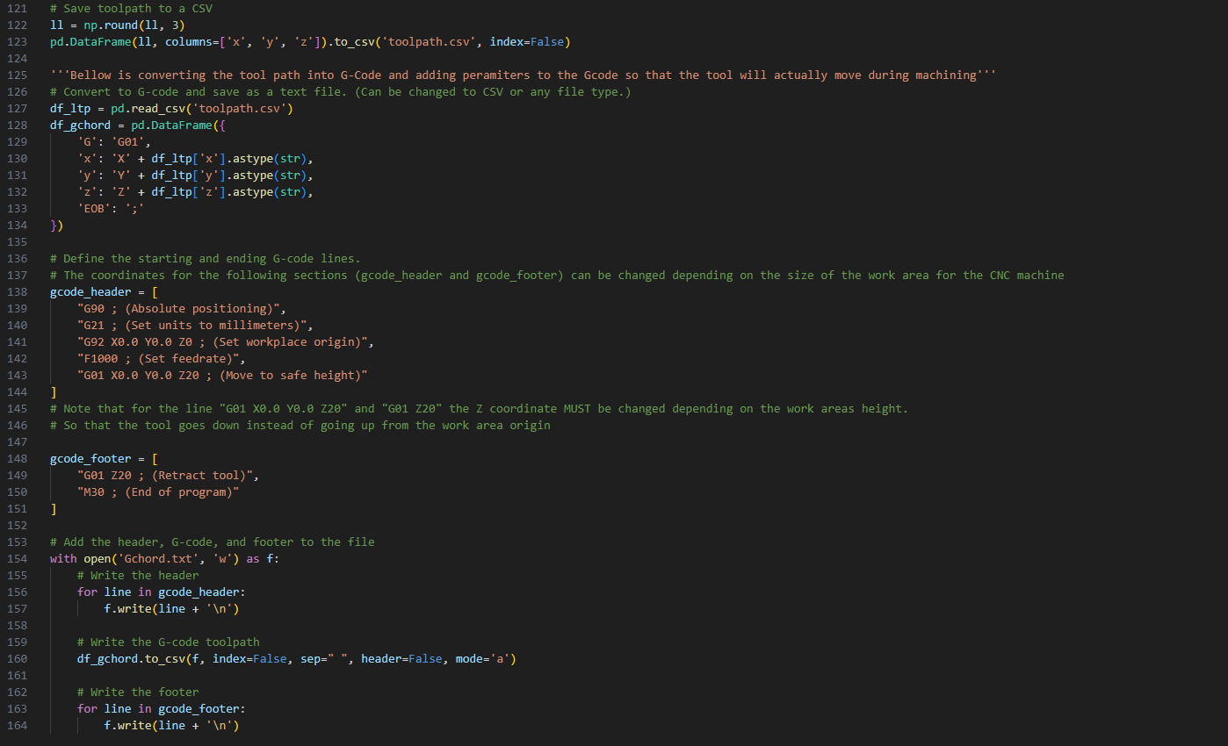
Figure 4.5: Finishing touches to the toolpath

  - Variables
A few variables are required for an accurate depiction and overall consistency of the tool path. The most important ones are mesh subdivisions, layer spacing, and tolerance. Mesh subdivisions divide each layer into parts so that more points are added to the tool path, giving a smoother tool path and making it less likely to have any problems. The layer spacing variable ensures that all the layers in the toolpath are the same distance apart. For example, layer one and layer two will have a 0.2 distance, and layer 10 and layer 11. The tolerance variable for the toolpath is a redundant measure to ensure that the toolpath does not have any issues when generating a circular shape vs. a shape with edges.

  - Modules
The “modules” or toolpath logic are groups of code that smooth out the processing of the tool path. If they were to be added to the toolpath generation logic seen in Figure X, the process of generating a toolpath would take a significantly larger amount of time. Things like TSP, which will be explained in the next section, and Clockwise processing are just some of the modules in the code.

  - TSP (Traveling Salesperson)
The most important module of the CAM system is the TSP logic. While the code in Figure 4.4 is also very important, the TSP logic ensures that the tool path will not double back on itself and create problems. The TSP logic does this by calculating the distances between the current point it is at and the points on the layer. After it does this, it will move the tool to the shortest distance point and repeat the process until all the points are reached. Something similar to the TSP logic was present in the previous researcher's research; however, it was adjusted so that other modules could be used to further optimize the code.

  - Processing loop overview
The process of toolpath generation involves several simple steps. First, the logic creates a variable so that the entire toolpath can be stored and later saved to a text file. Next, the toolpath generation will identify the highest Z coordinate or the highest layer of the figure, then eliminate any layers that have fewer than 3 points, as the module Convexhull, a module that selects the outermost points of a layer, cannot process layers that have fewer than 3 points. Then the Convexhull module selects the outermost points of the layer, and then the circular and noncircular processing modules are used to determine which type of processing to use. This redundant measure is here to ensure that nothing goes wrong with the TSP logic. The final part of the toolpath generation is moving to the next layer. The toolpath generation looks for the closest point on the next layer and saves that so the tool can return to that point later when it needs to move to the next layer. This creates a general area where the toolpath generation will always move to the next layer, cleaning up the toolpath visually. This will then repeat for the number of layers in the STL file.

  - General G-code addons
For the last section of the code, the general processing settings like spindle speed, setting the machine to absolute positioning, and setting the workplace origin are added to the beginning and end of the code so that the toolpath is ready to be put into the CNC machine right after the program is finished generating the G-code. These are found in the header and footer sections of the code and were explained in an earlier section.
The final part of the code, shown in Figure 4.5, is just to save the toolpath that was generated into a text file that can be directly put into the CNC machine.

  - NC viewer confirmation
After the CAM system generates the toolpath, to ensure that there are no issues with the toolpath, the NC viewer, an online website that can visualize the G-code, was used to ensure that there were no issues. The NC viewer is also a simulation of what will happen in the incremental forming process and can be edited as needed.
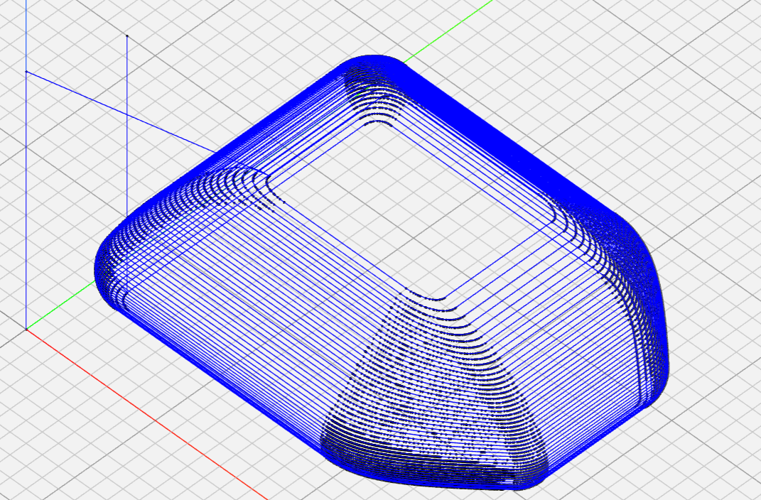
Figure X. NC viewer confirmation of the toolpath.

Chapter 5: Incremental forming Experiment
  - Plastic feasibility study of manufacturing
  - CFRTP testing
P A6 ( discontinuous fiber FRTP) , a resin with poor moldability , is heated to near its melting point using oil , and the resin is softened and then molded incrementally, assisting in the molding process. [1 8 ]

Chapter 6: Conclusion and Future Improvements

Chapter 7: References
- Taiga Mitsumori’s research paper
- Feasibility study of single pint incremental forming for discontinuoous fiber CFRP using oil bath heating
  - Tatsuki ikari and hidetake tanaka
- Feasibility study of laser assisted incrimental forming for carbon fiber reinforced thermo plastic based on 3D CAD data
  - Tatsuki ikari and hidetake tanaka
- Introduction to computation and programming using python 3rd edition
  - John v guttag
- Python all in one for dummies
  - John c shovic and alan simpson
- Principles and practices of CAD/CAM
  - Vikram sharma, Vikrant sharma, Om ji Shukla
- CNC programming techniques
  - Peter Smid

